Exercise 1: Configuring a Basic Spring Application
MainApp.java
package com.library.main;
import org.springframework.context.ApplicationContext;
import org.springframework.context.support.ClassPathXmlApplicationContext;
import com.library.service.BookService;
public class MainApp {
public static void main(String[] args) {
// Load Spring context from XML
ApplicationContext context = new ClassPathXmlApplicationContext("applicationContext.xml");
// Get bean and use it
BookService bookService = (BookService) context.getBean("bookService");
bookService.addBook("The Alchemist");
}
}

applicationContext.xml
<?xml version="1.0" encoding="UTF-8"?>
<beans xmlns="http://www.springframework.org/schema/beans"
xmlns:xsi="http://www.w3.org/2001/XMLSchema-instance"
xsi:schemaLocation="http://www.springframework.org/schema/beans
http://www.springframework.org/schema/beans/spring-beans.xsd">
<!-- Define BookRepository bean -->
<bean id="bookRepository" class="com.library.repository.BookRepository" />
<!-- Define BookService bean with dependency injection -->
<bean id="bookService" class="com.library.service.BookService">
<property name="bookRepository" ref="bookRepository" />
</bean>
</beans>\
BookService.java
package com.library.service;
import com.library.repository.BookRepository;
public class BookService {
private BookRepository bookRepository;
// Setter for Spring to inject the dependency
public void setBookRepository(BookRepository bookRepository) {
this.bookRepository = bookRepository;
}
public void addBook(String bookName) {
System.out.println("Service called to add book.");
bookRepository.saveBook(bookName);
}
}
BookRepository.java
package com.library.repository;
public class BookRepository {
public void saveBook(String bookName) {
System.out.println("Book saved to the repository: " + bookName);
}
}

OUTPUT
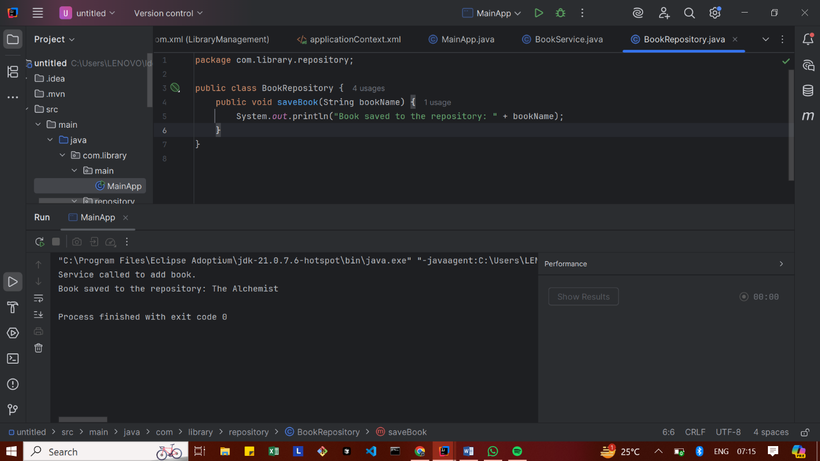

Exercise 2: Implementing Dependency Injection
applicationContext.xml
<?xml version="1.0" encoding="UTF-8"?>
<beans xmlns="http://www.springframework.org/schema/beans"
xmlns:xsi="http://www.w3.org/2001/XMLSchema-instance"
xsi:schemaLocation="http://www.springframework.org/schema/beans
http://www.springframework.org/schema/beans/spring-beans.xsd">
<!-- Define BookRepository bean -->
<bean id="bookRepository" class="com.library.repository.BookRepository" />
<!-- Define BookService bean and inject dependency -->
<bean id="bookService" class="com.library.service.BookService">
<property name="bookRepository" ref="bookRepository" />
</bean>
</beans>

BookService.java
package com.library.service;
import com.library.repository.BookRepository;
public class BookService {
private BookRepository bookRepository;
// ✅ Setter for dependency injection
public void setBookRepository(BookRepository bookRepository) {
this.bookRepository = bookRepository;
}
public void addBook(String bookName) {
System.out.println("Service called to add book.");
bookRepository.save(bookName);
}
}

MainApp.java
package com.library.main;
import org.springframework.context.ApplicationContext;
import org.springframework.context.support.ClassPathXmlApplicationContext;
import com.library.service.BookService;
public class MainApp {
public static void main(String[] args) {
// Load Spring context from XML
ApplicationContext context = new ClassPathXmlApplicationContext("applicationContext.xml");
// Get the BookService bean
BookService service = context.getBean("bookService", BookService.class);
// Test method
service.addBook("The Alchemist");
}
}

BookRepository.java
package com.library.repository;
public class BookRepository {
public void save(String bookName) {
System.out.println("Book saved: " + bookName);
}
}

OUTPUT
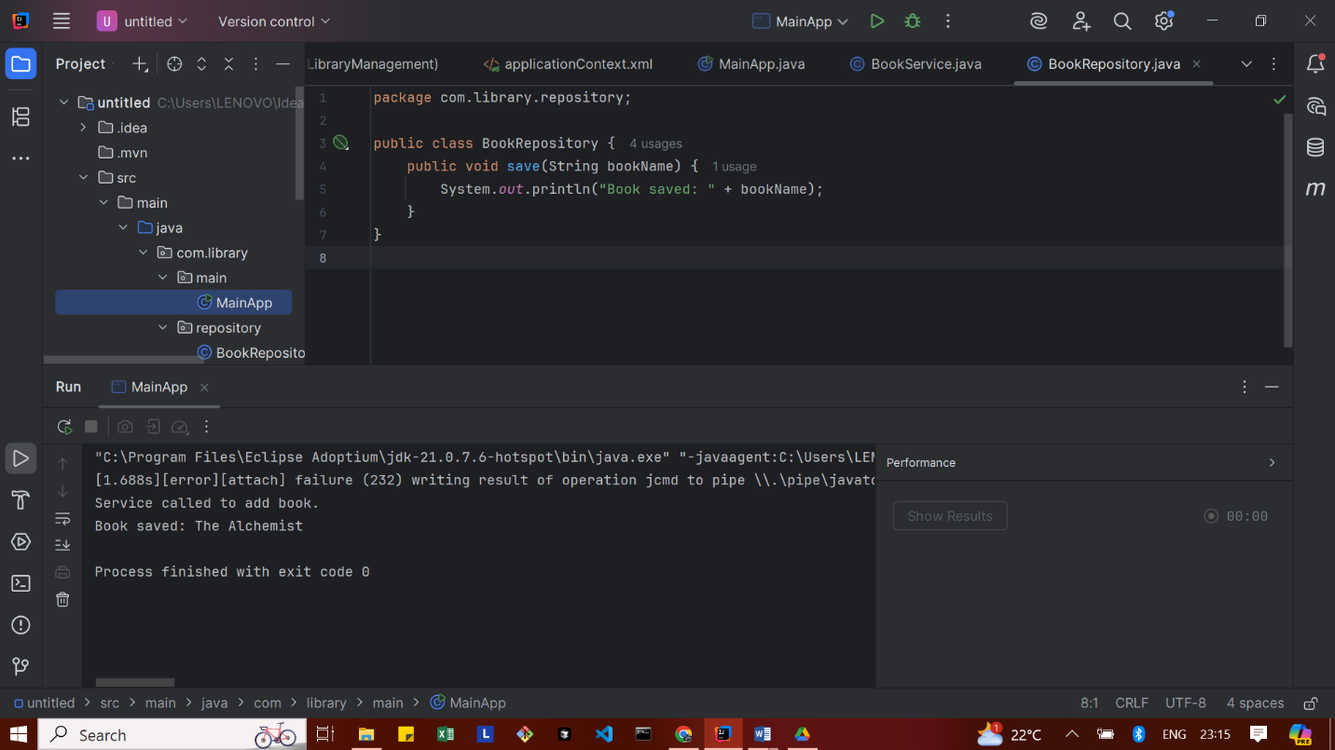

Exercise 3: Implementing Logging with Spring AOP

pom.xml
<?xml version="1.0" encoding="UTF-8"?>
<project xmlns="http://maven.apache.org/POM/4.0.0"
xmlns:xsi="http://www.w3.org/2001/XMLSchema-instance"
xsi:schemaLocation="http://maven.apache.org/POM/4.0.0
http://maven.apache.org/xsd/maven-4.0.0.xsd">
<modelVersion>4.0.0</modelVersion>
<groupId>com.library</groupId>
<artifactId>LibraryManagement</artifactId>
<version>1.0-SNAPSHOT</version>
<name>LibraryManagement</name>
<url>http://www.example.com</url>
<properties>
<project.build.sourceEncoding>UTF-8</project.build.sourceEncoding>
<maven.compiler.source>17</maven.compiler.source>
<maven.compiler.target>17</maven.compiler.target>
</properties>
<repositories>
<repository>
<id>central</id>
<url>https://repo.maven.apache.org/maven2</url>
</repository>
</repositories>
<dependencies>
<!-- ✅ Spring Context Dependency -->
<dependency>
<groupId>org.springframework</groupId>
<artifactId>spring-context</artifactId>
<version>5.3.31</version> <!-- Updated to latest compatible version -->
</dependency>
<!-- ✅ JUnit -->
<dependency>
<groupId>junit</groupId>
<artifactId>junit</artifactId>
<version>4.11</version>
<scope>test</scope>
</dependency>
<!-- Spring AOP -->
<dependency>
<groupId>org.springframework</groupId>
<artifactId>spring-aop</artifactId>
<version>5.3.20</version>
</dependency>
<!-- AspectJ Weaver -->
<dependency>
<groupId>org.aspectj</groupId>
<artifactId>aspectjweaver</artifactId>
<version>1.9.19</version>
</dependency>
</dependencies>
<build>
<pluginManagement>
<plugins>
<plugin>
<artifactId>maven-clean-plugin</artifactId>
<version>3.1.0</version>
</plugin>
<plugin>
<artifactId>maven-resources-plugin</artifactId>
<version>3.0.2</version>
</plugin>
<plugin>
<artifactId>maven-compiler-plugin</artifactId>
<version>3.8.0</version>
</plugin>
<plugin>
<artifactId>maven-surefire-plugin</artifactId>
<version>2.22.1</version>
</plugin>
<plugin>
<artifactId>maven-jar-plugin</artifactId>
<version>3.0.2</version>
</plugin>
<plugin>
<artifactId>maven-install-plugin</artifactId>
<version>2.5.2</version>
</plugin>
<plugin>
<artifactId>maven-deploy-plugin</artifactId>
<version>2.8.2</version>
</plugin>
<plugin>
<artifactId>maven-site-plugin</artifactId>
<version>3.7.1</version>
</plugin>
<plugin>
<artifactId>maven-project-info-reports-plugin</artifactId>
<version>3.0.0</version>
</plugin>
</plugins>
</pluginManagement>
</build>
</project>

LoggingAspect
package com.library.aspect;
import org.aspectj.lang.ProceedingJoinPoint;
import org.aspectj.lang.annotation.Around;
import org.aspectj.lang.annotation.Aspect;
@Aspect
public class LoggingAspect {
@Around("execution(* com.library.service.*.*(..))")
public Object logExecutionTime(ProceedingJoinPoint joinPoint) throws Throwable {
long start = System.currentTimeMillis();
Object result = joinPoint.proceed(); // execute the method
long end = System.currentTimeMillis();
System.out.println("Execution time of " + joinPoint.getSignature() + ": " + (end - start) + "ms");
return result;
}
}

applicationContext.xml
<beans xmlns="http://www.springframework.org/schema/beans"
xmlns:xsi="http://www.w3.org/2001/XMLSchema-instance"
xmlns:aop="http://www.springframework.org/schema/aop"
xsi:schemaLocation="http://www.springframework.org/schema/beans
http://www.springframework.org/schema/beans/spring-beans.xsd
http://www.springframework.org/schema/aop
http://www.springframework.org/schema/aop/spring-aop.xsd">
<!-- Enable AOP support -->
<aop:aspectj-autoproxy />
<!-- Register Repository -->
<bean id="bookRepository" class="com.library.repository.BookRepository" />
<!-- Register Service and inject Repository -->
<bean id="bookService" class="com.library.service.BookService">
<property name="bookRepository" ref="bookRepository" />
</bean>
<!-- Register Logging Aspect -->
<bean id="loggingAspect" class="com.library.aspect.LoggingAspect" />
</beans>

MainApp.java
package com.library.main;
import com.library.service.BookService;
import org.springframework.context.ApplicationContext;
import org.springframework.context.support.ClassPathXmlApplicationContext;
public class MainApp {
public static void main(String[] args) {
ApplicationContext context = new ClassPathXmlApplicationContext("applicationContext.xml");
BookService bookService = context.getBean("bookService", BookService.class);
bookService.addBook("Spring Framework");
}
}

OUTPUT
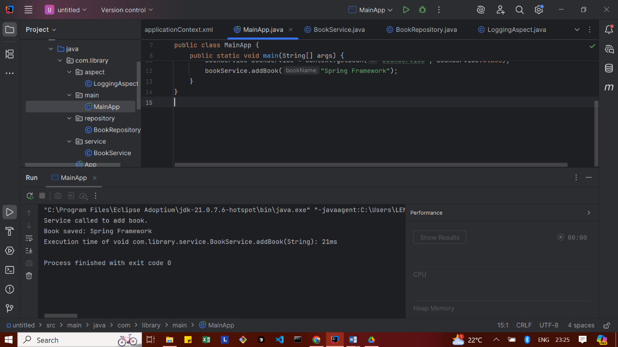

Exercise 4: Creating and Configuring a Maven Project
pom.xml
<?xml version="1.0" encoding="UTF-8"?>
<project xmlns="http://maven.apache.org/POM/4.0.0"
xmlns:xsi="http://www.w3.org/2001/XMLSchema-instance"
xsi:schemaLocation="http://maven.apache.org/POM/4.0.0
http://maven.apache.org/xsd/maven-4.0.0.xsd">
<modelVersion>4.0.0</modelVersion>
<groupId>com.library</groupId>
<artifactId>LibraryManagement</artifactId>
<version>1.0-SNAPSHOT</version>
<name>LibraryManagement</name>
<properties>
<project.build.sourceEncoding>UTF-8</project.build.sourceEncoding>
<maven.compiler.source>1.8</maven.compiler.source>
<maven.compiler.target>1.8</maven.compiler.target>
</properties>
<dependencies>
<!-- Spring Context -->
<dependency>
<groupId>org.springframework</groupId>
<artifactId>spring-context</artifactId>
<version>5.3.20</version>
</dependency>
<!-- Spring AOP -->
<dependency>
<groupId>org.springframework</groupId>
<artifactId>spring-aop</artifactId>
<version>5.3.20</version>
</dependency>
<!-- Spring Web MVC -->
<dependency>
<groupId>org.springframework</groupId>
<artifactId>spring-webmvc</artifactId>
<version>5.3.20</version>
</dependency>
<!-- AspectJ Runtime (for Spring AOP) -->
<dependency>
<groupId>org.aspectj</groupId>
<artifactId>aspectjweaver</artifactId>
<version>1.9.9</version>
</dependency>
<!-- JUnit for testing -->
<dependency>
<groupId>junit</groupId>
<artifactId>junit</artifactId>
<version>4.13.2</version>
<scope>test</scope>
</dependency>
</dependencies>
<build>
<plugins>
<!-- Maven Compiler Plugin -->
<plugin>
<artifactId>maven-compiler-plugin</artifactId>
<version>3.8.1</version>
<configuration>
<source>1.8</source>
<target>1.8</target>
</configuration>
</plugin>
</plugins>
</build>
</project>

OUTPUT
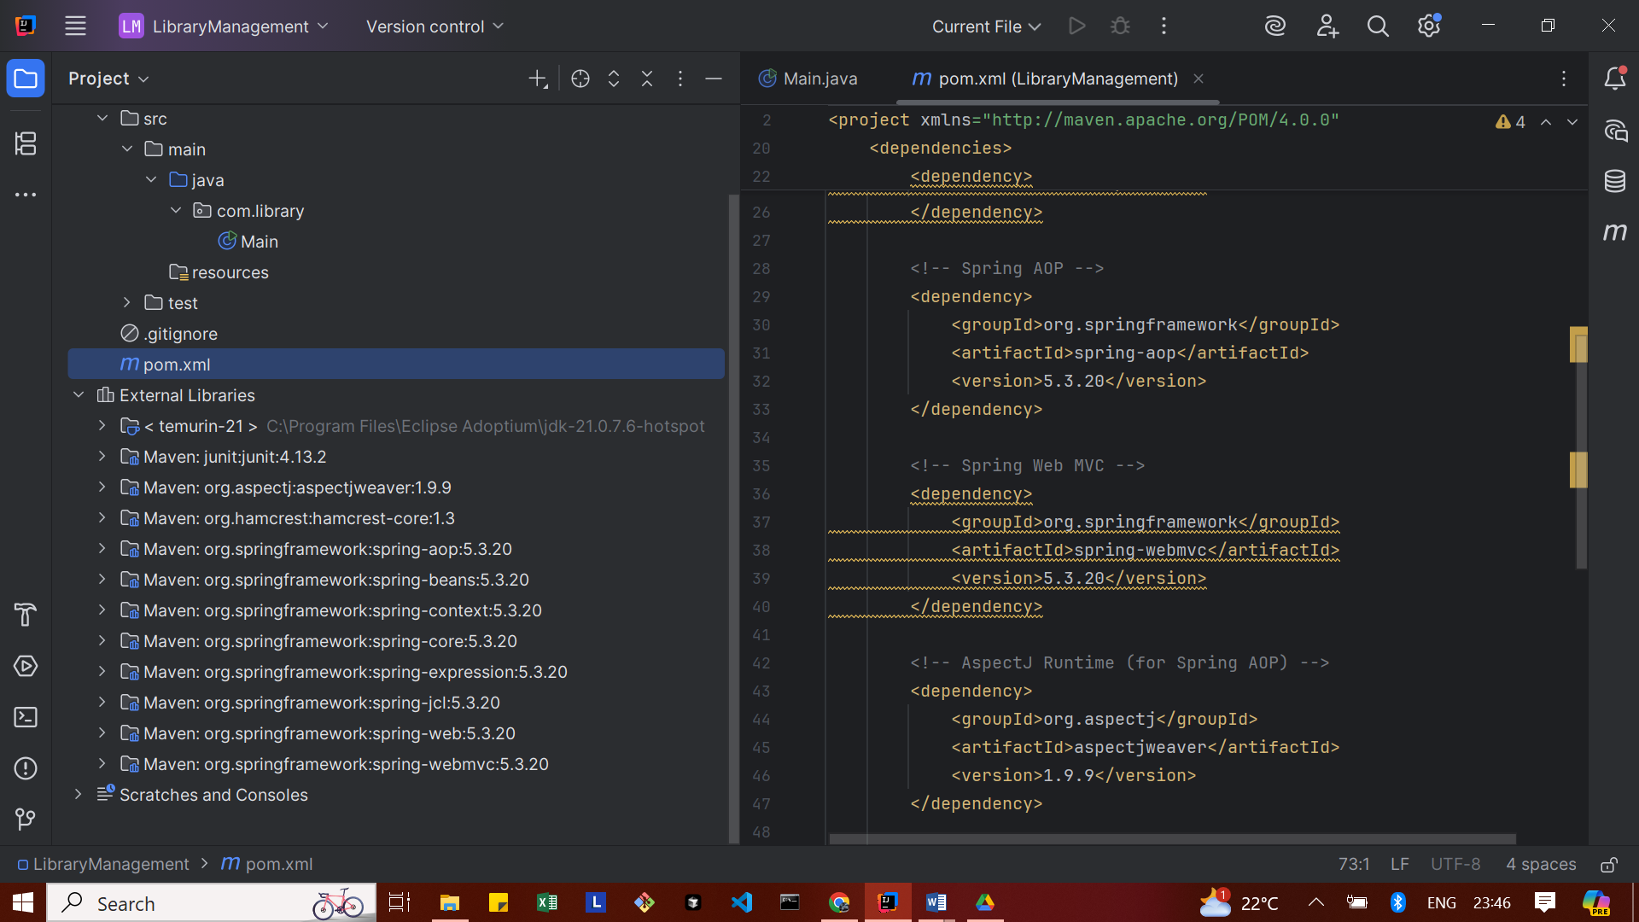

Exercise 5: Configuring the Spring IoC Container

pom.xml
<?xml version="1.0" encoding="UTF-8"?>
<project xmlns="http://maven.apache.org/POM/4.0.0"
xmlns:xsi="http://www.w3.org/2001/XMLSchema-instance"
xsi:schemaLocation="http://maven.apache.org/POM/4.0.0
http://maven.apache.org/xsd/maven-4.0.0.xsd">
<modelVersion>4.0.0</modelVersion>
<groupId>com.library</groupId>
<artifactId>LibraryManagement</artifactId>
<version>1.0-SNAPSHOT</version>
<name>LibraryManagement</name>
<properties>
<project.build.sourceEncoding>UTF-8</project.build.sourceEncoding>
<maven.compiler.source>1.8</maven.compiler.source>
<maven.compiler.target>1.8</maven.compiler.target>
</properties>
<dependencies>
<!-- Spring Context -->
<dependency>
<groupId>org.springframework</groupId>
<artifactId>spring-context</artifactId>
<version>5.3.20</version>
</dependency>
<!-- Spring AOP -->
<dependency>
<groupId>org.springframework</groupId>
<artifactId>spring-aop</artifactId>
<version>5.3.20</version>
</dependency>
<!-- Spring Web MVC -->
<dependency>
<groupId>org.springframework</groupId>
<artifactId>spring-webmvc</artifactId>
<version>5.3.20</version>
</dependency>
<!-- AspectJ Runtime (for Spring AOP) -->
<dependency>
<groupId>org.aspectj</groupId>
<artifactId>aspectjweaver</artifactId>
<version>1.9.9</version>
</dependency>
<!-- JUnit for testing -->
<dependency>
<groupId>junit</groupId>
<artifactId>junit</artifactId>
<version>4.13.2</version>
<scope>test</scope>
</dependency>
</dependencies>
<build>
<plugins>
<!-- Maven Compiler Plugin -->
<plugin>
<artifactId>maven-compiler-plugin</artifactId>
<version>3.8.1</version>
<configuration>
<source>1.8</source>
<target>1.8</target>
</configuration>
</plugin>
</plugins>
</build>
</project>

applicationContext.xml
<?xml version="1.0" encoding="UTF-8"?>
<beans xmlns="http://www.springframework.org/schema/beans"
xmlns:xsi="http://www.w3.org/2001/XMLSchema-instance"
xsi:schemaLocation="
http://www.springframework.org/schema/beans
http://www.springframework.org/schema/beans/spring-beans.xsd">
<!-- BookRepository Bean -->
<bean id="bookRepository" class="com.library.repository.BookRepository" />
<!-- BookService Bean with DI -->
<bean id="bookService" class="com.library.service.BookService">
<property name="bookRepository" ref="bookRepository" />
</bean>
</beans>

MainApp.java
package com.library.main;
import com.library.service.BookService;
import org.springframework.context.ApplicationContext;
import org.springframework.context.support.ClassPathXmlApplicationContext;
public class MainApp {
public static void main(String[] args) {
ApplicationContext context = new ClassPathXmlApplicationContext("applicationContext.xml");
BookService bookService = context.getBean("bookService", BookService.class);
bookService.addBook("Spring In Action");
}
}

BookService.java
package com.library.service;
import com.library.repository.BookRepository;
public class BookService {
private BookRepository bookRepository;
public void setBookRepository(BookRepository bookRepository) {
this.bookRepository = bookRepository;
}
public void addBook(String bookName) {
System.out.println("Service called to add book.");
bookRepository.save(bookName);
}
}

BookRepository.java
package com.library.repository;
public class BookRepository {
public void save(String bookName) {
System.out.println("Book '" + bookName + "' saved to the repository.");
}
}

OUTPUT
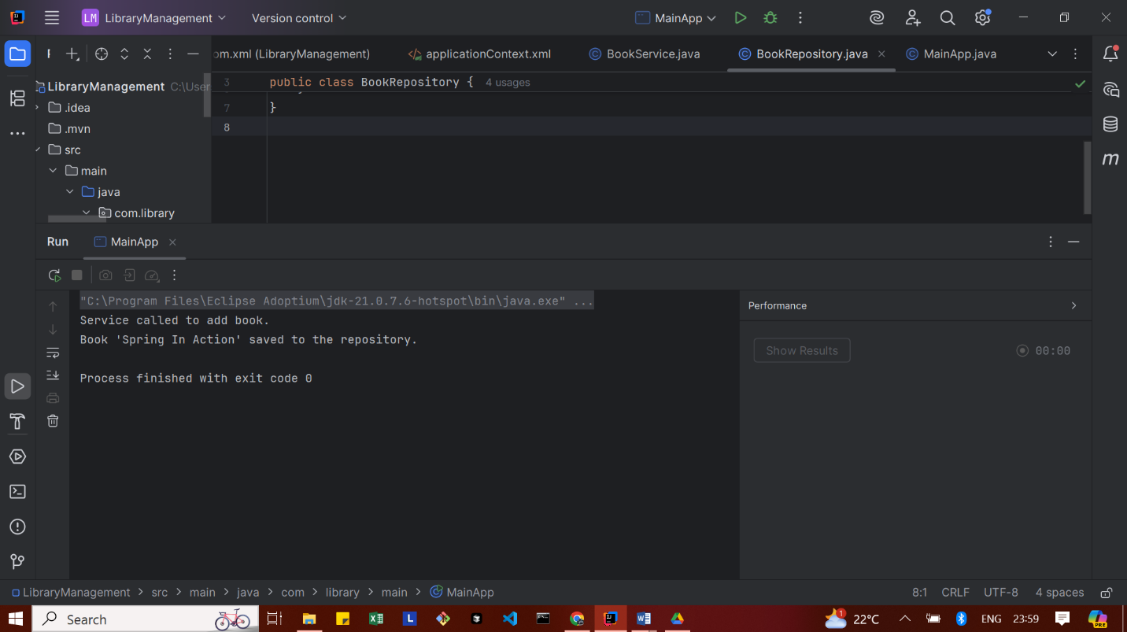

Exercise 6: Configuring Beans with Annotations
applicationContext.xml
<?xml version="1.0" encoding="UTF-8"?>
<beans xmlns="http://www.springframework.org/schema/beans"
xmlns:context="http://www.springframework.org/schema/context"
xmlns:xsi="http://www.w3.org/2001/XMLSchema-instance"
xsi:schemaLocation="
http://www.springframework.org/schema/beans
http://www.springframework.org/schema/beans/spring-beans.xsd
http://www.springframework.org/schema/context
http://www.springframework.org/schema/context/spring-context.xsd">
<!-- ✅ Enable Component Scanning -->
<context:component-scan base-package="com.library"/>
</beans>
BookRepository.java
package com.library.repository;
import org.springframework.stereotype.Repository;
@Repository
public class BookRepository {
public void save(String bookName) {
System.out.println("Book '" + bookName + "' saved to the repository.");
}
}

BookService.java
package com.library.service;
import com.library.repository.BookRepository;
import org.springframework.beans.factory.annotation.Autowired;
import org.springframework.stereotype.Service;
@Service
public class BookService {
@Autowired
private BookRepository bookRepository;
public void addBook(String bookName) {
System.out.println("Service called to add book.");
bookRepository.save(bookName);
}
}

MainApp.java
package com.library.main;
import com.library.service.BookService;
import org.springframework.context.ApplicationContext;
import org.springframework.context.support.ClassPathXmlApplicationContext;
public class MainApp {
public static void main(String[] args) {
ApplicationContext context = new ClassPathXmlApplicationContext("applicationContext.xml");
BookService bookService = context.getBean(BookService.class);
bookService.addBook("Spring In Action");
}
}

OUTPUT
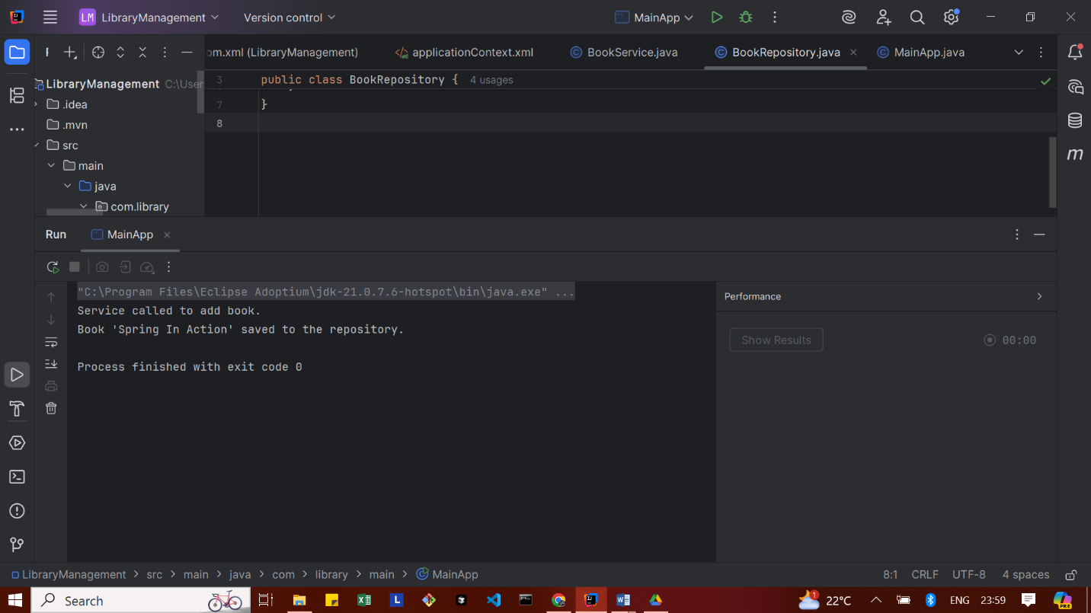
Exercise 7: Implementing Constructor and Setter Injection
applicationContext.xml
<?xml version="1.0" encoding="UTF-8"?>
<beans xmlns="http://www.springframework.org/schema/beans"
xmlns:xsi="http://www.w3.org/2001/XMLSchema-instance"
xsi:schemaLocation="
http://www.springframework.org/schema/beans
http://www.springframework.org/schema/beans/spring-beans.xsd">
<!-- BookRepository Bean -->
<bean id="bookRepository" class="com.library.repository.BookRepository" />
<!-- BookService Bean with constructor + setter injection -->
<bean id="bookService" class="com.library.service.BookService">
<!-- ✅ Constructor injection -->
<constructor-arg value="Welcome to Library Management!" />
<!-- ✅ Setter injection -->
<property name="bookRepository" ref="bookRepository" />
</bean>
</beans>

BookService.java
package com.library.service;
import com.library.repository.BookRepository;
public class BookService {
private BookRepository bookRepository;
private String message;
// ✅ Constructor injection
public BookService(String message) {
this.message = message;
}
// ✅ Setter injection
public void setBookRepository(BookRepository bookRepository) {
this.bookRepository = bookRepository;
}
public void addBook(String bookName) {
System.out.println("Message: " + message);
System.out.println("Service called to add book.");
bookRepository.save(bookName);
}
}

MainApp.java
package com.library.main;
import com.library.service.BookService;
import org.springframework.context.ApplicationContext;
import org.springframework.context.support.ClassPathXmlApplicationContext;
public class MainApp {
public static void main(String[] args) {
ApplicationContext context = new ClassPathXmlApplicationContext("applicationContext.xml");
BookService bookService = context.getBean("bookService", BookService.class);
bookService.addBook("Effective Java");
}
}

OUTPUT
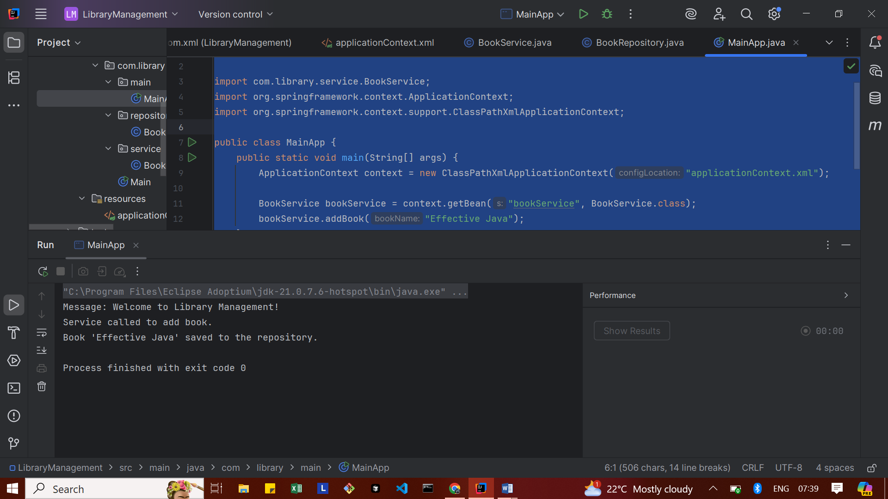
Exercise 8: Implementing Basic AOP with Spring
applicationContext.xml
<?xml version="1.0" encoding="UTF-8"?>
<beans xmlns="http://www.springframework.org/schema/beans"
xmlns:context="http://www.springframework.org/schema/context"
xmlns:aop="http://www.springframework.org/schema/aop"
xmlns:xsi="http://www.w3.org/2001/XMLSchema-instance"
xsi:schemaLocation="
http://www.springframework.org/schema/beans
http://www.springframework.org/schema/beans/spring-beans.xsd
http://www.springframework.org/schema/context
http://www.springframework.org/schema/context/spring-context.xsd
http://www.springframework.org/schema/aop
http://www.springframework.org/schema/aop/spring-aop.xsd">
<!-- Enable component scanning -->
<context:component-scan base-package="com.library"/>
<!-- Enable AOP auto-proxying -->
<aop:aspectj-autoproxy />
</beans>

LoggingAspect.java
package com.library.aspect;
import org.aspectj.lang.JoinPoint;
import org.aspectj.lang.annotation.After;
import org.aspectj.lang.annotation.Aspect;
import org.aspectj.lang.annotation.Before;
import org.springframework.stereotype.Component;
@Aspect
@Component
public class LoggingAspect {
@Before("execution(* com.library.service.BookService.*(..))")
public void logBefore(JoinPoint joinPoint) {
System.out.println("[AOP] Before method: " + joinPoint.getSignature().getName());
}
@After("execution(* com.library.service.BookService.*(..))")
public void logAfter(JoinPoint joinPoint) {
System.out.println("[AOP] After method: " + joinPoint.getSignature().getName());
}
}

MainApp.java
package com.library.main;
import com.library.service.BookService;
import org.springframework.context.ApplicationContext;
import org.springframework.context.support.ClassPathXmlApplicationContext;
public class MainApp {
public static void main(String[] args) {
ApplicationContext context = new ClassPathXmlApplicationContext("applicationContext.xml");
BookService bookService = context.getBean("bookService", BookService.class);
bookService.addBook("Effective Java");
}
}

BookService.java
package com.library.service;
import com.library.repository.BookRepository;
import org.springframework.beans.factory.annotation.Autowired;
import org.springframework.stereotype.Service;
@Service // ✅ Marks this class as a Spring bean named "bookService"
public class BookService {
private BookRepository bookRepository;
private String message;
// ✅ Constructor injection
@Autowired
public BookService() {
this.message = "Welcome to Library Management!";
}
// ✅ Setter injection (for BookRepository)
@Autowired
public void setBookRepository(BookRepository bookRepository) {
this.bookRepository = bookRepository;
}
public void addBook(String bookName) {
System.out.println("Message: " + message);
System.out.println("Service called to add book.");
bookRepository.save(bookName);
}
}

BookRepository.java
package com.library.repository;
import org.springframework.stereotype.Repository;
@Repository // ✅ Register as Spring bean
public class BookRepository {
public void save(String bookName) {
System.out.println("Book '" + bookName + "' saved to the repository.");
}
}

OUTPUT
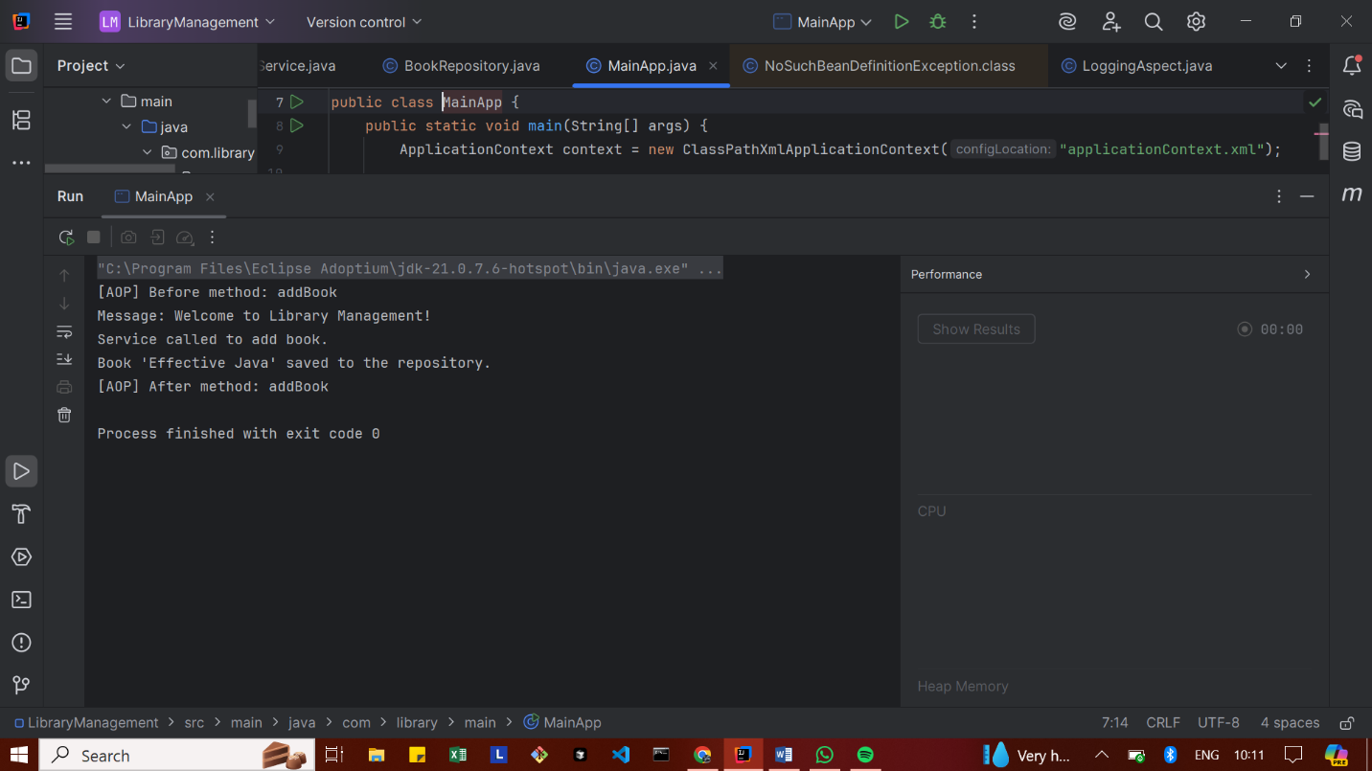

Exercise 9: Creating a Spring Boot Application
pom.xml
<?xml version="1.0" encoding="UTF-8"?>
<project xmlns="http://maven.apache.org/POM/4.0.0"
xmlns:xsi="http://www.w3.org/2001/XMLSchema-instance"
xsi:schemaLocation="http://maven.apache.org/POM/4.0.0
http://maven.apache.org/xsd/maven-4.0.0.xsd">
<modelVersion>4.0.0</modelVersion>
<parent>
<groupId>org.springframework.boot</groupId>
<artifactId>spring-boot-starter-parent</artifactId>
<version>3.2.5</version>
<relativePath/> <!-- lookup parent from repository -->
</parent>
<groupId>com.library</groupId>
<artifactId>LibraryManagement</artifactId>
<version>1.0.0</version>
<name>LibraryManagement</name>
<properties>
<java.version>17</java.version>
</properties>
<dependencies>
<!-- Spring Boot Web Starter -->
<dependency>
<groupId>org.springframework.boot</groupId>
<artifactId>spring-boot-starter-web</artifactId>
</dependency>
<!-- Spring Boot JPA Starter -->
<dependency>
<groupId>org.springframework.boot</groupId>
<artifactId>spring-boot-starter-data-jpa</artifactId>
</dependency>
<!-- H2 In-Memory Database -->
<dependency>
<groupId>com.h2database</groupId>
<artifactId>h2</artifactId>
<scope>runtime</scope>
</dependency>
<!-- Spring Boot Test -->
<dependency>
<groupId>org.springframework.boot</groupId>
<artifactId>spring-boot-starter-test</artifactId>
<scope>test</scope>
</dependency>
</dependencies>
<build>
<plugins>
<!-- Spring Boot Maven Plugin -->
<plugin>
<groupId>org.springframework.boot</groupId>
<artifactId>spring-boot-maven-plugin</artifactId>
</plugin>
</plugins>
</build>
</project>

application.properties
spring.datasource.url=jdbc:h2:mem:librarydb
spring.datasource.driverClassName=org.h2.Driver
spring.datasource.username=sa
spring.datasource.password=
spring.jpa.database-platform=org.hibernate.dialect.H2Dialect
spring.h2.console.enabled=true
spring.jpa.hibernate.ddl-auto=update

MainApp.java
package com.library;
import org.springframework.boot.SpringApplication;
import org.springframework.boot.autoconfigure.SpringBootApplication;
@SpringBootApplication
public class MainApp {
public static void main(String[] args) {
SpringApplication.run(MainApp.class, args);
}
}

BookController.java
package com.library.controller;
import com.library.model.Book;
import com.library.repository.BookRepository;
import org.springframework.beans.factory.annotation.Autowired;
import org.springframework.web.bind.annotation.*;
import java.util.List;
@RestController
@RequestMapping("/books")
public class BookController {
@Autowired
private BookRepository bookRepository;
@GetMapping
public List<Book> getAllBooks() {
return bookRepository.findAll();
}
@PostMapping
public Book createBook(@RequestBody Book book) {
return bookRepository.save(book);
}
@GetMapping("/{id}")
public Book getBookById(@PathVariable Long id) {
return bookRepository.findById(id).orElse(null);
}
@PutMapping("/{id}")
public Book updateBook(@PathVariable Long id, @RequestBody Book updatedBook) {
Book book = bookRepository.findById(id).orElse(null);
if (book != null) {
book.setTitle(updatedBook.getTitle());
book.setAuthor(updatedBook.getAuthor());
return bookRepository.save(book);
}
return null;
}
@DeleteMapping("/{id}")
public void deleteBook(@PathVariable Long id) {
bookRepository.deleteById(id);
}
}

Book.java
package com.library.model;
import jakarta.persistence.Entity;
import jakarta.persistence.GeneratedValue;
import jakarta.persistence.GenerationType;
import jakarta.persistence.Id;
@Entity
public class Book {
@Id
@GeneratedValue(strategy = GenerationType.IDENTITY)
private Long id;
private String title;
private String author; // ✅ NEW FIELD
public Book() {
}
public Book(String title, String author) {
this.title = title;
this.author = author;
}
public Book(Long id, String title, String author) {
this.id = id;
this.title = title;
this.author = author;
}
// ✅ Getters and Setters
public Long getId() {
return id;
}
public void setId(Long id) {
this.id = id;
}
public String getTitle() {
return title;
}
public void setTitle(String title) {
this.title = title;
}
public String getAuthor() { // ✅ Needed to fix error
return author;
}
public void setAuthor(String author) { // ✅ Needed to fix error
this.author = author;
}
@Override
public String toString() {
return "Book{" +
"id=" + id +
", title='" + title + '\'' +
", author='" + author + '\'' +
'}';
}
}

BookRepository.java
package com.library.repository;
import com.library.model.Book;
import org.springframework.data.jpa.repository.JpaRepository;
public interface BookRepository extends JpaRepository<Book, Long> {
}

OUTPUT
